NT3 Pauline 1, Romans
Dr. Marvin J. Effa
Author: Paul
Date of writing: 57-58 A.D.
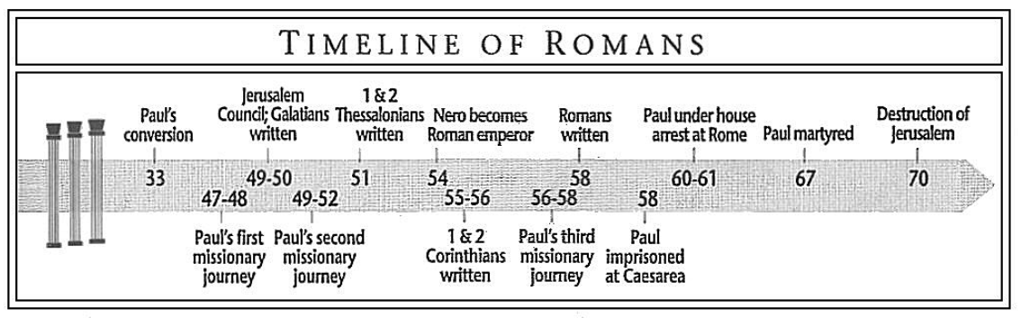
Purpose: to provide a comprehensive statement of Paul’s theology as he prepares for a new work in Spain.

Idea: God’s righteousness provided by faith through the work of Christ allows the Spirit to empower us to live lives pleasing to God and worthy of reward.

Development:

- Introduction to the letter: Paul is eager to preach the Gospel in Rome, 1:1-15.
- God will accurately judge everyone, 1:16-3:20.
  - The benefits of God’s righteousness are experienced through believing the Gospel and walking by faith, 1:16-17. (The Gospel uncovers [(reveals, makes known “apokalupetai”) God’s righteousness to those who believe in Jesus and walk by faith.]
  - God’s judgment is right because everyone knows better, 1:18-3:20.
    - Knowledge from creation, 1:20-32.
    - Knowledge from conscience, 2:1-5.
[Theme of Romans: God rewards those who do good and punishes those who do evil, 2:6-11. (Everlasting life is a reward in Romans.)]
  - Jewish unbelievers do not escape God’s judgement on the world, 2:12-3:8.
  - Everyone who does not believe and walk by faith is guilty, 3:9-20.
- God’s righteousness is freely given to both Jew and Gentile by faith in Christ’s blood, 3:21-31. (“Has been revealed” is a different word than in 1:17 & 18; here the word is “pephanerotai”- Perfect, Passive Indicative 3S; it means to make clear, manifest, open, conspicuous, visible, etc.)
- Abraham is proof that righteousness comes by believing and walking by faith, 4:1-25.
  - Unbelieving, ungodly, uncircumcised Abraham believed and was declared righteous, 4:1-5.
  - David, a believing king, a prophet, and a Jew, was reckoned righteous apart from works, 4:6-8.
  - Abraham’s experience with righteousness was a model for both Jew and Gentile to believe and walk by faith, 4:9-12
  - The promise of reward comes to both Jews and Gentiles through faith and not works, 4:13-17a.
  - Abraham proves believing and walking by faith actually results in righteous living, 4:17b-22.
  - Jesus rose from the dead to provide reckoned righteousness to ungodly people who believe and as believers, walk by faith, 4:23-25.
- As believers walking by faith, we can boast, 5:1-11:
  - Of a future glory that comes from God, 5:1-2 (NB “glory” reference to 2:6-11).
  - In our current troubles, because the indwelling Spirit pours on us the resurrected Christ’s love and future deliverance from wrath, 5:3-10 (NB “wrath” reference to 2:6-11).
  - In God because of Christ’s reconciling work, 5:11.
- As Adam brought the reign of death on the entire race, those believing and walking by faith are receiving righteousness and will reign in life so that we are rewarded with everlasting life, 5:12-21 (NB “everlasting life” reference to 2:6-11).
- Grace should motivate us unto righteousness, not sin, 6:1-14.
- Grace frees us from the law and should motivate us unto holy living, which receives the reward of everlasting life, 6:15-7:6 (NB “everlasting life” reference to 2:6-11).
- The law identifies and incites indwelling sin; the unaided believer practices sin, not holiness, 7:7-25.
- The indwelling Spirit desires to empower believers to walk righteously, 8:1-11.
- The Gentiles’ rewards and participation in the millennium does not mean Israel has been cast off, 8:12-11:36.
  - The Spirit wishes to lead believers out of judgement and into rewards as we suffer with Christ, 8:12-17.
  - Suffering with Christ now is insignificant when compared to the future glory in eternity 8:18-30 (NB “glory” reference to 2:6-11).
  - Unbelieving Jews are offended by faith in Jesus, 9:1-33.
    - Paul is grieved over Israel’s unbelief, 9:1-5.
    - God is free to show mercy on Israel and Gentile nations and individuals, 9:6-24.
    - Gentiles, and only a few of the Jews, will believe, 9:25-33.
  - God has made it easy for all who desire salvation to be delivered, 10:1-21.
  - Israel is temporarily in a fog of unbelief, but all of the Remnant will believe, 11:1-36.
- God’s grace in justification and the Spirit’s righteous empowerment provide the foundation for living a life pleasing to the Lord, 12:1-15:13.
  - Grace has been given to us that we might minister to the body of Christ, 12:1-21.
  - Grace living submits to the government and one’s neighbors, 13:1-14.
  - Grace living minimizes insignificant differences and pursues peace with others in the church, 14:1- 15:13
    - The Judgement Seat of Christ includes disagreements over doubtful things, 14:1-12.
    - Behave in a way that does not damage the weaker brother, 14:13-15:6.
    - Jesus receives both Jews and Gentiles to himself, and so should we, 15:7-13.
- Concluding remarks: Paul hopes to come to Rome on his way to Spain (15:14-33); he passes along greetings of other believers and churches (16:1-24), and concludes with a benediction (16:25-27).

Places and Dates of the Writings of the New Testament Epistles
Decade | Books | Places | Dates
A.D. 40–49 | James | Jerusalem | A.D. 45–48
 | Galatians | Antioch of Syria | 40–49, after Paul’s first missionary journey
50–59 | 1 Thessalonians | Corinth | 50–54, in Paul’s second missionary journey
 | 2 Thessalonians | Corinth | 50–54, in Paul’s second missionary journey
 | 1 Corinthians | Ephesus | About 56, in Paul’s third missionary journey
 | 2 Corinthians | Macedonia | About 56, in Paul’s third missionary journey
 | Romans | Corinth | 57, in Paul’s third missionary journey
60–69 | Ephesians | Rome | 60
 | 1 John | Ephesus | 60–65
 | 2 John | Ephesus | Early 60s
 | 3 John | Ephesus | Early 60s
 | Philippians | Rome | 60–61
 | Colossians | Rome | 60–62
 | Philemon | Rome | 60–62
 | 1 Timothy | Macedonia? | 63–66
 | Titus | Macedonia? | 63–66
 | 1 Peter | Rome? | 64
 | Jude | ? | 67–80
 | 2 Timothy | Rome | 67
 | 2 Peter | Rome? | 67–68
 | Hebrews | ? | 68–69

